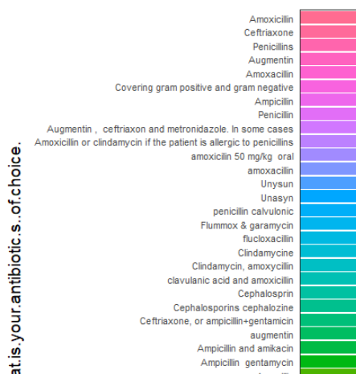

1. Some antibiotics are repeated
2. Do we need to form groups of similar antibiotics?

Answer:

Done

Antibiotics are classified into 2 classes; generic name and antibiotic category

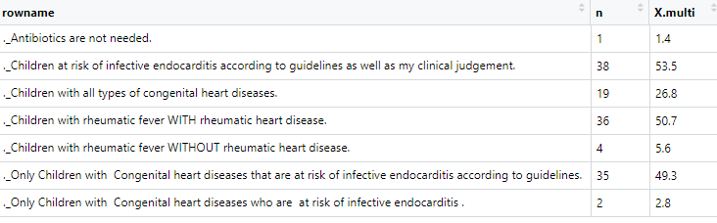

Do we need to group any of these responses ? , this last answer is not in the questionnaire?

Answer: I think it can be added to the previous response

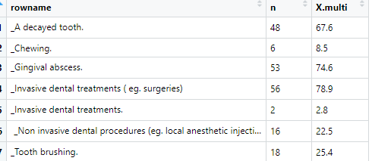

Do we need to group any of these responses ? (invasive ttt for example) . this answer is repeated. We can group chewing and tooth brushing – Invasive dental treatment answer is repeated and can be grouped together

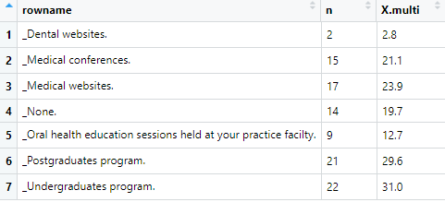

Do we need to group any of these responses ? we can group medical conferences and websites as (medical sources,eg websites and conferences)

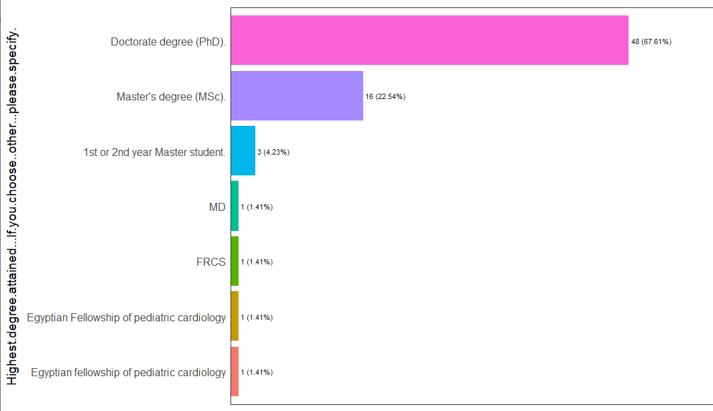

Do we need to group any of these responses ? (MD, FRCS, and Egyptian fellowship can be grouped with doctorate degree)